**Week 2: Design Refinement & Materialization**

1. This week's course arrangements

|  |  |  |  |  |
| --- | --- | --- | --- | --- |
| **No.** | **Date** | **Topic** | **Instructor** | **Course Objectives** |
| 2 | 10/09 | Refine and materialize the design of column and pavilion/dormitory corridor wall, model in Blender | Prof. Bin Jiang,  Fuhou Zhang | 1. Refine the column design based on the 15 principles of living structure; 2. Refine the design of pavilion/dormitory corridor wall; 3. Finalize the Blender model for 3D printing and laser cutting. |
| Time Arrangement:  19:30-20:30 Refine and materialize the design of column and pavilion/dormitory corridor walls.  20:30-21:30 Model in Blender.  Venue: E1-103 | | | | |

1. Main tasks for this week's hands-on practice
2. Column Design

Each student should design a column based on the 15 principles of Living Structure.

* Mandatory Tasks:

1. Show your column model in Blender.
2. Demonstrate your sketches on paper or in computer, explaining the levels of scale and other principles of your design.

* Optional Task (assignment on the class):

1. Prepare a 3D model of your column design for 3D printing.
2. Pavilion / Dormitory Corridor Wall Design

* Mandatory Tasks:

1. Demonstrate your sketches on paper or in computer, explaining the levels of scale and other principles of your design.
2. Choose a few principles your team would like to use in the design.

* Optional Task (assignment on the class):

1. Build a 3D model of your preliminary design scheme in Blender.

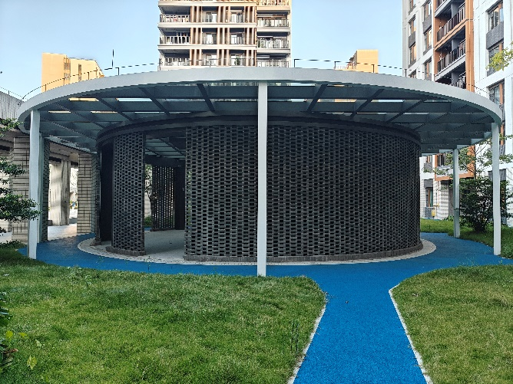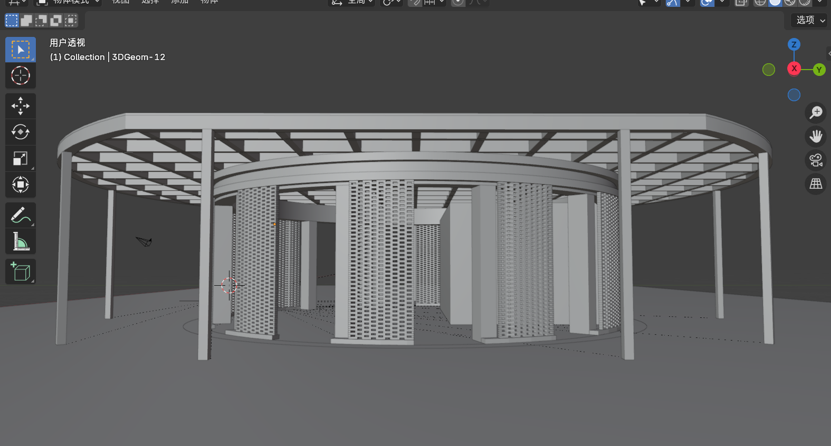

**Figure: pavilion besides the Cai Niao Post House**

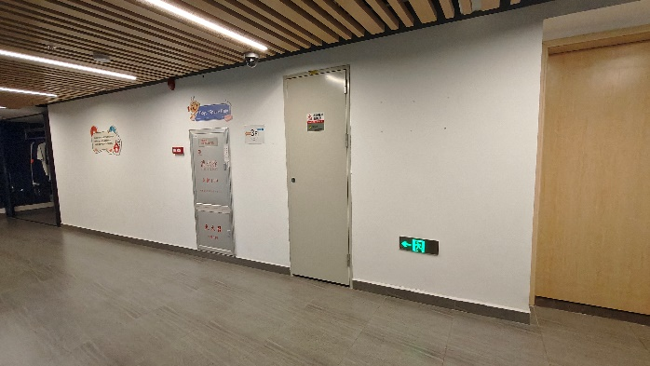 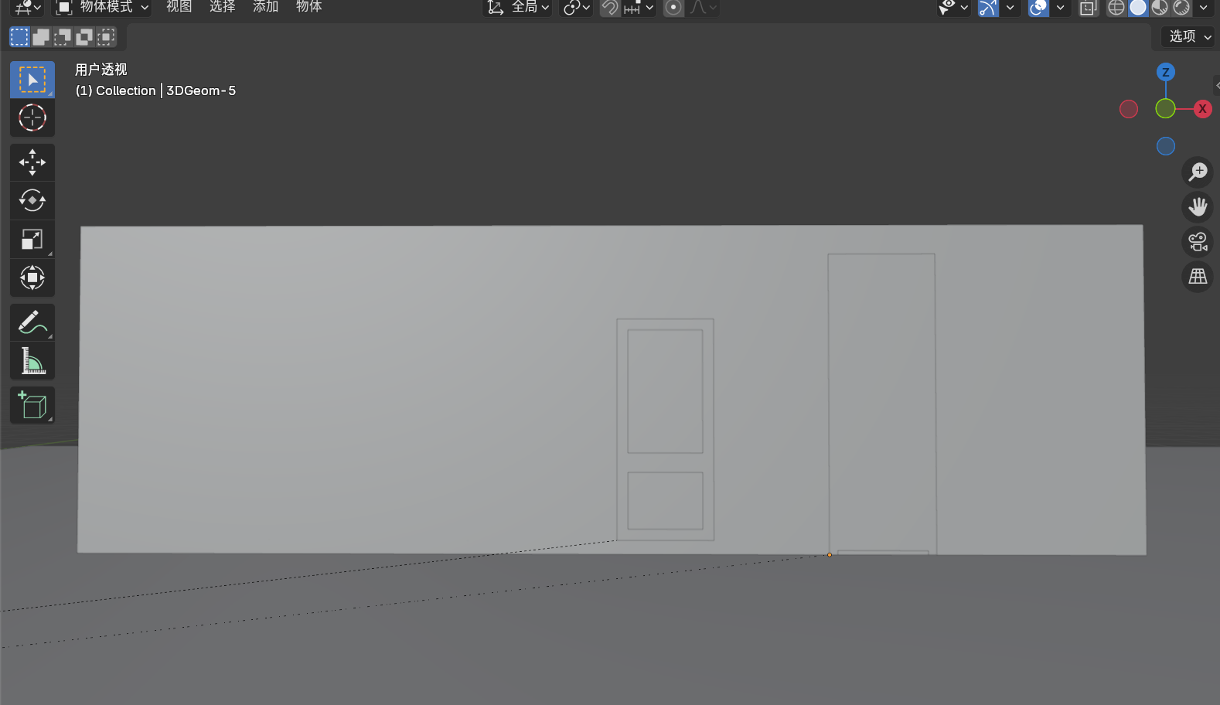

**Figure: the wall facing elevators on 3rd floor of 5A dormitory**

1. 3D Printing Modeling Instructions
2. **Overview**

This guide provides step-by-step instructions for creating a 3D model for printing, focusing on efficient and accurate design techniques to achieve high-quality prints.

1. **Introduction to the 3D Printer: Bambu X1E and Software**

The **Bambu X1E** is a high-performance 3D printer known for its speed, accuracy, and multi-material printing capabilities. It is ideal for both prototyping and complex design projects.

* **Key Features**:
  + **High Speed**: Prints up to 500 mm/s, significantly reducing production time.
  + **Multi-Material Compatibility**: Supports a variety of filaments like PLA, ABS, PETG, and flexible materials.
  + **Auto-Bed Leveling**: Automatically calibrates the print bed for consistent quality.
  + **Enclosed Chamber**: Provides a stable environment for temperature-sensitive materials.

**Bambu Studio**: The Bambu X1E uses **Bambu Studio** software for slicing and preparing 3D models for printing. This software is user-friendly and designed specifically to optimize print quality and speed for the Bambu X1E.

* + **Slicing Settings**: Allows for detailed adjustments like layer height, infill density, print speed, and support structures.
  + **Multi-Material Handling**: Enables easy configuration of multi-material prints, with options to manage different colors and types of filament.
  + **Real-Time Monitoring**: Bambu Studio provides real-time monitoring, letting users track the print progress and adjust settings if necessary.

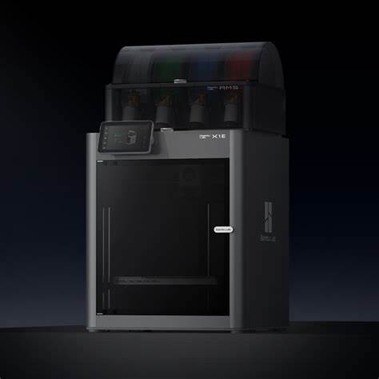 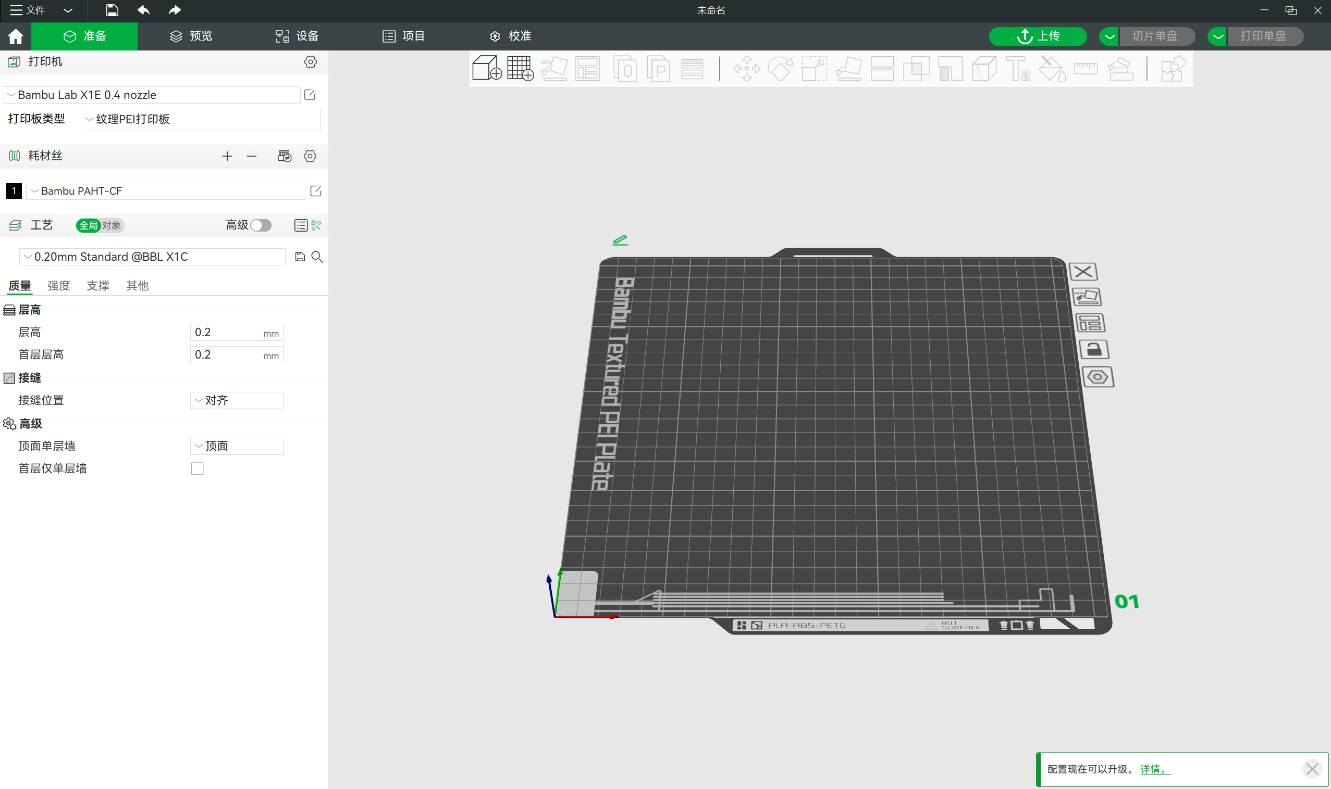

**Figure: Bamboo X1E Figure: Bamboo Studio**

1. **Integrating Blender with Bambu Studio for 3D Printing**

To prepare models created in **Blender** for printing with the Bambu X1E, follow these steps:

1. **Export from Blender**:
   * **File Format**: Export the model from SketchUp as an **OBJ file**, which is compatible with most 3D printing software, including Bambu Studio.
   * **Export Path**: In Blender, go to **File > Export > Wavefront(obj.)** as the file format. Ensure the units are set correctly (e.g., millimeters) to maintain accurate scaling.
2. **Import to Bambu Studio**:
   * Open **Bambu Studio** and import the OBJ file by selecting **File > Import** or dragging the OBJ file directly into the software.
   * **Scale and Position**: Adjust the model’s size, orientation, and position on the print bed as needed. Bambu Studio allows you to rotate, scale, and arrange the model to optimize for minimal support usage.
3. **Slicing Settings**:
   * Customize slicing settings like **layer height**, **infill density**, **print speed**, and **supports** based on the model’s requirements.
   * Bambu Studio provides pre-set profiles for the Bambu X1E, ensuring optimized settings for various materials and print qualities.

**For more detailed information, you can refer to:** [**https://wiki.bambulab.com/zh/home**](https://wiki.bambulab.com/zh/home)

1. **Key Modeling Considerations for 3D Printing**

When creating models for 3D printing, certain design considerations are crucial to ensure printability, structural integrity, and high quality. Here are some important aspects to keep in mind:

1. **Wall Thickness:**
   * Avoid walls that are too thin, as they may result in weak structures. A minimum of 0.8-2 mm is recommended for stability, especially for smaller parts.

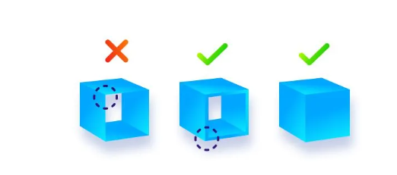

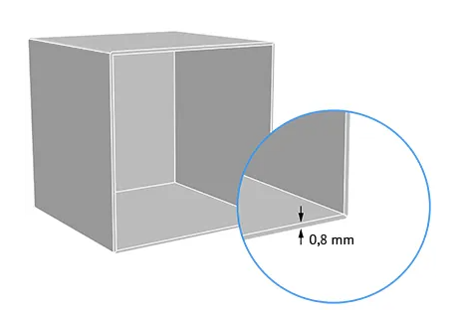

1. **Ov****erhangs and Supports:**
   * 3D printers struggle with steep overhangs. Keep overhang angles below 45 degrees to avoid the need for excessive supports.
   * If overhangs are necessary, consider adding support structures during the slicing process in Bambu Studio.

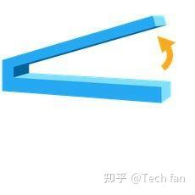

1. **Minimum Detail Requirements:**

Protruding Details: For raised details, like printed text or logos, ensure a minimum thickness and height of 0.1mm. Anything less may not be visible or may blend into the surface of the model.



Indented Details: For recessed details, such as grooves or indentations, ensure a minimum depth of 0.4mm. Details shallower than this may not be distinct after printing, as they may blend into surrounding areas.

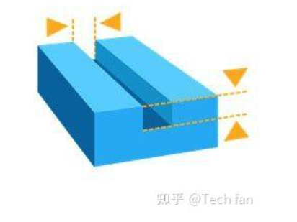

1. **Ensure a Manifold (Watertight) Model**

For successful printing, the model must be a manifold geometry, meaning it should have a closed surface with no gaps or non-manifold edges. A manifold model ensures that all 3D shapes have volume, and no surfaces are left open or with intersecting edges that the printer cannot interpret.

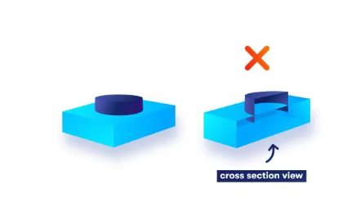

If your model has any non-manifold geometry, such as shared edges (T-junctions) or single-point intersections (bowtie geometry), resolve these by adjusting the surfaces to eliminate intersecting or shared edges.

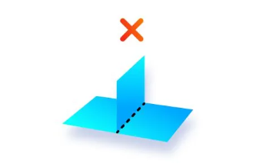

Tip: Avoid overly detailed or complex designs that may result in large file sizes, slowing down the slicing process. Simplify geometry where possible, especially for small or hidden features.

**For more on these guidelines, see the reference articles:**

* <https://zhuanlan.zhihu.com/p/367155032>；
* <https://zhuanlan.zhihu.com/p/269972231>；
* <https://mp.weixin.qq.com/s/4J8IwGSLU0-y1EqQ8X4UVg>；
* <https://mp.weixin.qq.com/s/A-I85S9t517n--rrC6vjWA>